Suppose you want to analyze Chemokine signaling pathway

1. Open pathway in browser

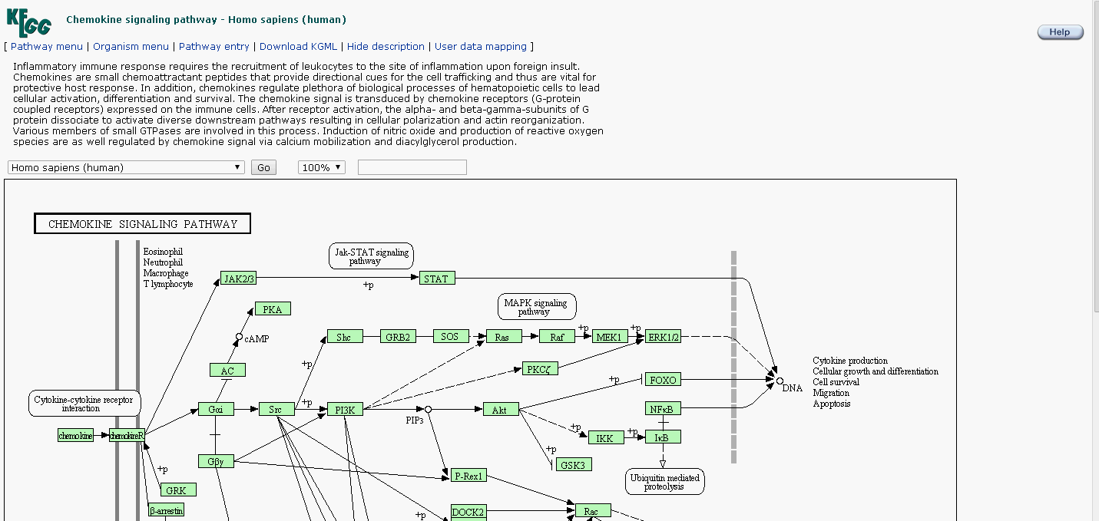

2. Download KGML file and save it somewhere

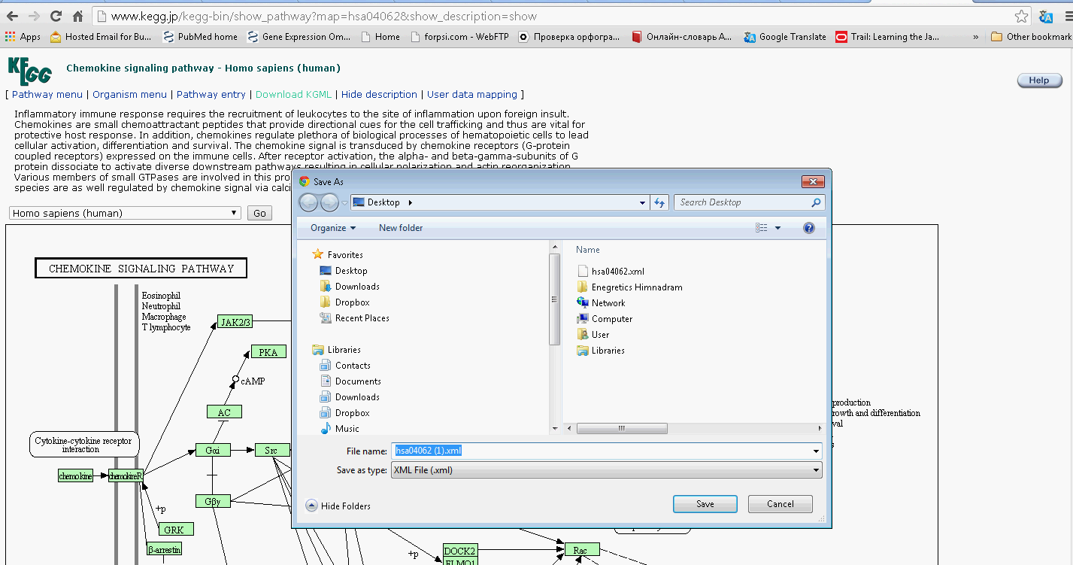

3. Open downloaded file with text editor

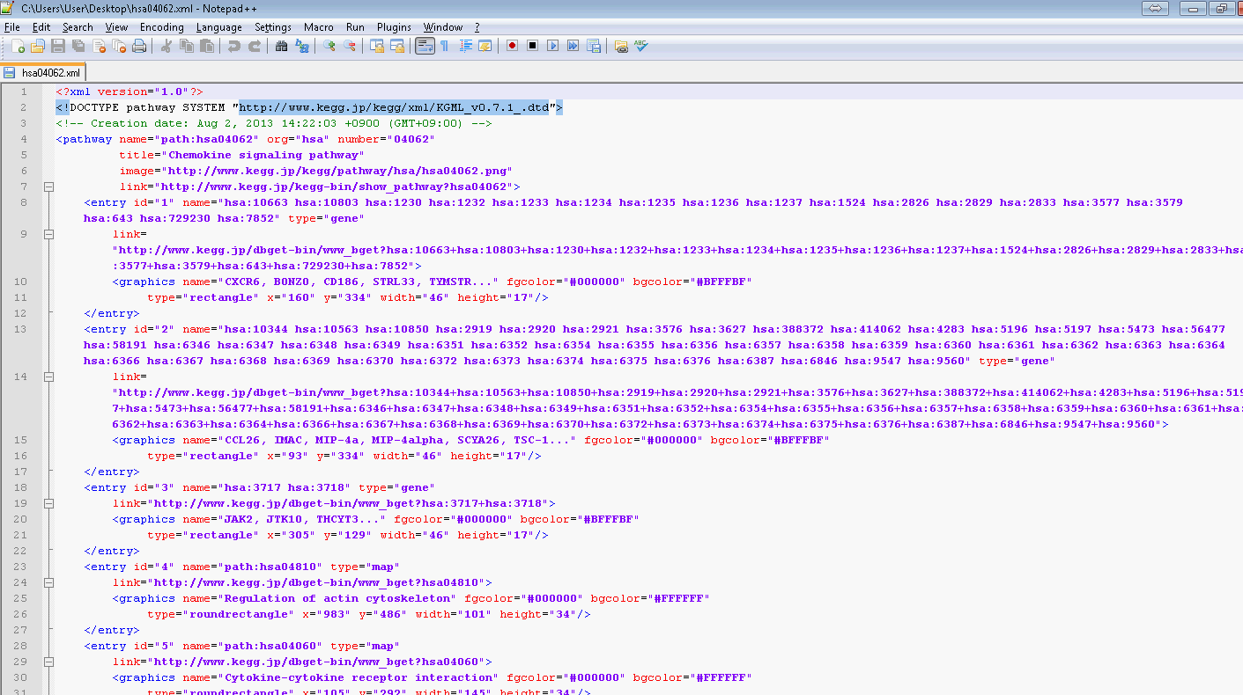

You need to comment this line see next section

4. Comment “Doctype line” and save KGML file

<!DOCTYPE pathway SYSTEM "http://www.kegg.jp/kegg/xml/KGML_v0.7.1_.dtd"> should become

<!--DOCTYPE pathway SYSTEM "http://www.kegg.jp/kegg/xml/KGML_v0.7.1_.dtd" -->

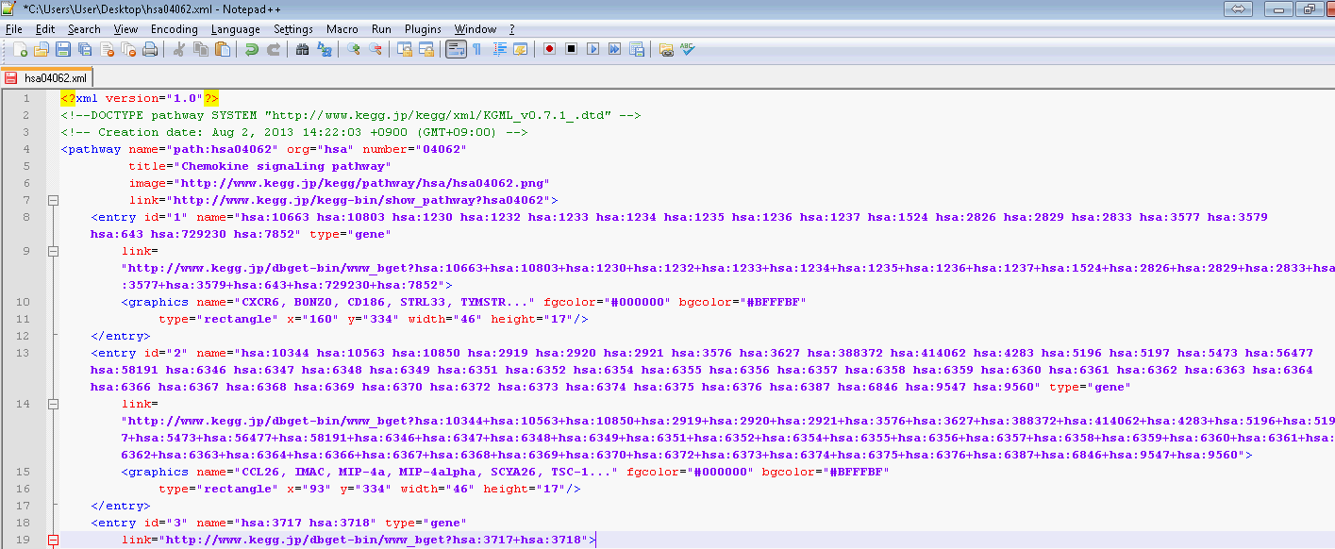

5. Load saved file in KP with **“load local xml”** button

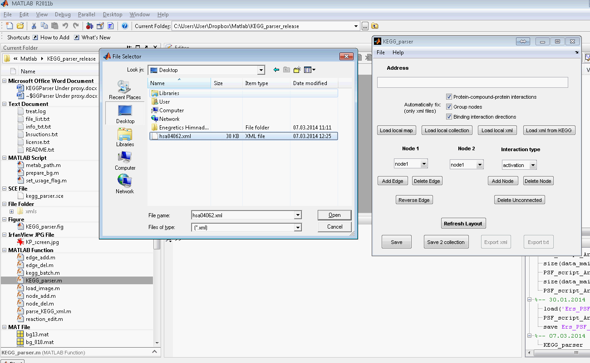

6. That’s it

